Ysgol Bryn Pennant


Governors’ Report to Parents

2023 - 2024


Ysgol Bryn Pennant
Governor's Report to Parents 2023 - 2024
Autumn Term 2024

This report is for parents and guardians of pupils at Ysgol Bryn Pennant, Mostyn. The National Assembly for Wales requires that an Annual report on their governance of the school is delivered to parents and guardians in the Autumn Term of each academic year.
-------oOo--------
Contents of the Report
Governors
Governors Meetings
Our Mission Statement
Safeguarding
School Prospectus
Estyn Inspection and Post Inspection Action Plan
The School Development Plan and Our Development Priorities
Well Being
Grant Funding
New Curriculum for Wales
Class Organisation and Staffing
Numbers on Roll (November 2023)
Catering
The School Buildings and Grounds
Security Arrangements/Health and Safety
Parents Evenings
School Council
After School Clubs
School News and Community Links
Friends of Ysgol Bryn Pennant
Healthy Schools Policy
Swimming
Additional Educational Needs
Staff Training
School Results 2023 - 2024
Pupils with Disabilities
School Budget
Expenditure Summary
Attendance
School Holiday Dates and Training Days
Closing Statement by Chair of Governors

Governors

All school Governors are appointed for a four year term. The school year runs from September to July each following year. This report is on the period from September 2023 to the end of the summer term in July 2024. During the academic year 2023-2024, the Governing Body met on the dates listed below.
Minutes are kept of all Governors meetings by the Clerk to the Governors, Mrs Debbie Newton. Any queries regarding the work and minutes of the Governing Body should be directed to the Clerk of Governors or the Headteacher. Governors are able to claim legitimate expenses from the school budget. As yet no expenses have been claimed.

Ysgol Bryn Pennant Governors 2023 - 2024
Parent Governors
Emily Lovgren
Amy Teodorescu
Vacancy

Education Authority Governors
Cllr. Patrick Heesom
Cllr. Pam Banks
Mr Michael Lewis-Jones (Chair)

Minor Authority Governor
Mr David Seddon

Community Governors
Mrs Lin Jones (Vice Chair)
Mrs Kristian Howells
Mrs Vicky Hughes

Staff Governors
Miss Karen Welsh
Mrs Anwen Howells

Headteacher
Miss Dawn Wood

Clerk to Governors
Mrs Debbie Newton

Governors’ Meetings

Autumn Term 2023 | 19th October: AGM  30th November 2023: ALN and Curriculum Meeting
Spring Term 2024 | 14th March 2024
Summer Term 2024 | 4th July 2024

Our Mission Statement
In Ysgol Bryn Pennant we strive to provide a broad and balanced education, enabling our learners to become confident, independent individuals with a thirst for life-long learning. We pride ourselves on being a supportive, inclusive community, with wellbeing at its heart.

Safeguarding
The safety and welfare of all our children is given the highest priority.
Children from Early Years to Year 2 are not permitted to leave the school unaccompanied and must be collected by a responsible adult at the end of the school day.
Parents are also welcome to collect their children from Year 3 upwards however, these children are allowed to walk home at the end of the school day if their parents so wish.
Children who travel on the school bus to Rhewl will be accompanied to the bus by a member of staff. We ask that these children are met by a parent when they get off the bus in Rhewl.
We have developed our curriculum to include learning opportunities to support the safeguarding of our children.
If you have any concerns for any of the children please do not hesitate to contact any of the key people listed below:
The Designated Person for child protection at Ysgol Bryn Pennant is:
Miss D. A. Wood, Headteacher
The Deputy Designated Person for child protection at Ysgol Bryn Pennant is:
Mrs L. Roberts, A.L.N.Co.
The Nominated Governor for child protection at Ysgol Bryn Pennant is:
Mr. M. Lewis-Jones, Chair of Governors
The Flintshire County Council Lead Officer for Safeguarding in Education is:
Mrs Vicky Barlow. Contact number: 01352 752121
Flintshire County Council’s Children’s Services can be contacted as follows:
Duty and Assessment Team. Contact number: 01352 701000
Out of Hours phone number (Duty Social Worker): 0845 053 3116

School Prospectus

The school prospectus is updated annually. It outlines our core values and contains information to help parents develop an understanding of how our school operates. It is routinely given to prospective parents when they visit the school. Copies of the prospectus are always available free on request to the school office. It will also be on our new school website which we are currently developing.

Estyn Inspection & Post Inspection Action Plan

The school last underwent an Estyn Inspection in June 2017. The school’s performance by Estyn was judged to be good and its prospects for improvement are also good.
Following the inspection, a Post Inspection Action Plan has been developed to address the recommendations. There were five recommendations in total. The school will continue to review its own performance through self-evaluation and the findings will inform the School Development Plan. Self-evaluation is a rigorous, continuous process, which is monitored, on a termly basis, by the school’s new GwE Supporting Improvement Advisor, Paul Davies. This process will continue to be examined by external Inspectors.
The School Development Plan

Central to the running of the school is its improvement plan, which sets out in a written format a plan of the school's vision and purpose. The School Development Plan (SDP) is a written record of how the school is managing the business of delivering an education and learning provision for our school community. It is a key document for example that school Inspectors focus on in their review of a school. The SDP is under constant review on a three year cycle containing action plans and priorities for development over three years. A copy of the latest version is always available in school.

The School Development Plan is reviewed regularly by the Senior Leadership Team (SLT) and Governors. The priorities within the SDP are discussed in each of our meetings with Governors. This year we have invited our governors to become members of our curriculum teams which will help our governors to develop further within their monitoring roles. If parents have any queries on the content of any school policy, they should contact the Headteacher.

Our Development Priorities for 2023 – 2024 were:

Priority One: Continue to Implement the Curriculum for Wales and further develop learning opportunities through innovation to support wellbeing for all.

Priority Two: Through the implementation of the New Code for Additional Learning Needs, ensure that tailored provision is in place for all who need support.

Priority Three: Develop Learners Language, Literacy and Communication Skills in both English and Welsh across all areas of learning.

Priority Four: Ensure that learners of all ages have appropriate and regular

Our SLT regularly monitor the school’s progress towards these priorities throughout the year.

Progress is also externally monitored by Paul Davies, our GwE Supporting Improvement Advisor. In addition, each Spring Term GwE monitor teaching and learning through visits to school. Paul met with teams of staff to help us review our progress and to decide on the next steps on our improvement journey.

The Welsh Assembly Government has given a range of duties and powers to governing bodies under legislation. Governing bodies have a general responsibility for the conduct of their school with a view to promoting high standards of educational achievement. These include: -

- Managing the school’s budget in accordance with the Local Authorities financing scheme for maintained schools
- Making sure that the school’s curriculum is balanced and broadly based and in particular that the curriculum includes the National Curriculum and religious education.
- Reporting assessments and examination results to parents and the LA.
- Reporting results of the Statutory National tests to parents and the LA.
- Ensuring the appointment of the teachers and staff and determining how they will be managed including the provisions for staff discipline, complaints and grievances.
- Establishing in consultation with staff, a performance management and staff appraisal policy.
- Managing governors’ duties to pupils with Additional Educational Needs
- Drawing up an Action Plan following Inspections

Wellbeing

Ysgol Bryn Pennant continues to be a nurturing school where the care and wellbeing of our children remains our highest priority.

Attendance is one area of particular concern and the way Flintshire supports primary schools with this has now changed. We have a new EWO in place and she is very pro-active in supporting the school and our families who are struggling with school attendance.

Throughout the school communication with parents has continued through text messaging (through Schoolcomms) as well as via email. These systems have facilitated closer and more regular communication between staff and parents and feedback from all stakeholders has been positive.

Grant Funding

In 2023–2024, the E.I.G.funding was once again used to provide additional staffing which enabled the provision of basic skills support, delivered by some of our support staff.

The Education Improvement Grant (E.I.G.) is used to provide training for staff according to need and linked to the priorities identified in our School Development Plan.

The Pupil Deprivation Grant (PDG) and the Early Years Pupil Deprivation Grant (EYPDG) are the Welsh Government’s principal means of supporting schools to reduce the impact of a disadvantaged background on the educational attainment of pupils who receive Free School Meals (FSM) or who are Looked After Children (LAC).

The PDG is intended to overcome the additional barriers that some learners face which prevent them from attaining as well as their peers, whatever their ability.

The targets for the PDG plan in 2023 – 2024 focused on:

●Promoting well being through maintaining small classes
●Promoting engagement with learning in both the indoor and outdoor environments
●Narrowing the gap in attainment between pupils on F.S.M and non F.S.M. pupils through staffing to deliver and support interventions

‘Forest School’ activities were provided for groups of children from Year 2 to Year 6 by Miss McAdam, our trained forest school lead.

The Accelerated Learning Grant was provided to schools to support children who had experienced additional barriers to learning due to Covid. In 2023 – 2024 we used our Accelerated Learning Grant to provide additional hours for two Teaching Assistants to support children who were particularly disadvantaged by Covid.

Professional Learning Grant provides access to professional development which is needed as staff prepare for the education reforms in Wales. In 2023 – 2024 we used our grant to release staff for training so that our new ALOE teams could meet and staff could access training in other local schools. ALNCo was also released so that she could attend training opportunities as we continued to prepare for the new ALN Code.

New Curriculum for Wales

Wales is currently undergoing a period of considerable educational reform. The New Curriculum become statutory in September 2022 and we have reorganized our classes within school to reflect this change. Classes are organized in Progression Steps rather than the previous National Curriculum Year groups.

Class organization and Staffing

From Little Acorns, Mighty Oaks Grow

Our Early Years class, which is made up of our Nursery and Reception children was taught by Miss McAdam and Miss Warburton. Miss McAdam taught in the morning, and Miss Warburton, in the afternoon. This is our Progression Step One class.

They have further developed ‘Planning in the Moment’ which gives children more choice in the activities they select and can be tailored to the interests and strengths of individuals. This has also increased parental engagement with learning which is something we would like to continue to build upon.

Miss McAdam has also undertaken the woodwork training and has set up an area in the Beehive where children are able to create small models using a variety of real tools. Again, this is something that we are hoping to develop into other age groups as we move forward.

Miss Seddon taught a class of Years 1 and 2 in Dosbarth Celyn. The children enjoyed a wide range of experiences in all areas of learning.
This class also benefited from Miss Seddon’s expertise in BSL.

Mrs Roberts taught a class of Years 2 and 3 in Dosbarth Helygen. (Progression Step 2). This class contained some of our most vulnerable children.

Miss Welsh taught Year 4 and younger Year 5 in Dosbarth Sycamorwydden. (Progression Step 3). The number of ALN children in this class was high and Miss Welsh had a variety of specific interventions in place to support these children.

Mrs Francis-Owen continued to teach Dosbarth Derwen (Years 5 and 6 / Progression Step 3). The children from this class support their younger peers from across the school.

In 2023-2024 the school roll remained steady. Our Local Authority admission number is 18 children per Year Group.

We welcomed a small number of Early Entitlement children into school in the Spring Term and in the Summer Term. These children attended along with our nursery children from 8.55 a.m. - 11.30 a.m. each day.

Numbers on Roll (November 2023)

Pupil Numbers  Nov. 2023 | Class | Boys | Girls | Total in Class
Nursery | Mesen Bach  (Little Acorns) | 1 | 8
Reception | Mesen Bach  (Little Acorns) | 4 | 7 | 20
Year 1 | Dosbarth Celyn  (Dosbarth Holly) | 2 | 13
Year 2 | Dosbarth Celyn  (Dosbarth Holly) | 2 | 3 | 20
Year 2 | Dosbarth Helygen  (dosbarth Willow) | 5 | 4
Year 3 | Dosbath Helygen  (Dosbath Willow) | 9 | 4 | 22
Year 4 | Dosbarth Sycaorwyddeb  (Dosbarth Sccamore)) | 8 | 8
Year 5 | Dosbarth Sycamorwydden  (Dosbarth Sycamore) | 4 | 5 | 25
Year 5 | Dosbarth Derwen  (Dosbarth Oak) | 4 | 3
Year 6 | Dosbarth Derwen  (Dosbarth Oak) | 10 | 10 | 27
Totals |  | 49 | 65 | 114
In addition to the support provided for children with ALN within their classes, Mrs Debbie Seddon and Auntie De also provided focused and bespoke support.

Mrs Lynn Hughes, Mrs Maree Williams, Miss Lyndsey Roberts, Miss Kelly Bennett and Miss Nikki Hennessey worked within the classes to provide support for the children.

In September our four Midday Supervisory Assistants were Mrs De Sharp, Mrs Anwen Howells, Miss Kelly Bennett and Miss Nikki Hennessey.

Catering
Newydd Catering continue to run the school meals and our meals are now prepared in the Central Production Kitchen in Mold and delivered to school each day. Mrs. Susan Jones and Auntie Jackie our catering assistants, work in the kitchen to ensure that the children are served their meals each day.
The school continues to run a very successful Breakfast Club, providing free breakfasts to between 60 and 65 pupils each morning. In September, Breakfast Club was run by Susan Jones, Paula Mills and Auntie Sophie.

Breakfast begins at 8.15am and closes at 8.45am, and offers pupils a choice of cereals, toast, fruit juice or milk as well as fruit. The children have access to a variety of resources and activities thus ensuring that they are happily engaged and can spend time with their friends before they go into class to start the school day.

The school was cleaned and maintained by the school caretaker Mrs. Tina Davies assisted by Mrs Heather Jones and Mrs Marie Luke. Mrs Heather Jones decided to take voluntary redundancy at the end of the summer term after many years of supporting our school.

All our administration is undertaken by our Office Manager, Mrs Debbie Newton.

The School Buildings and Grounds

Our building is showing signs of age in some areas and this year we have had Capital Funding from Flintshire County Council to replace the surface of the entire length of the flat roof. We are still experiencing some ingress of water in several parts of the building when the rain is particularly heavy.
The works are extensive and will continue into the the next academic year (2023 - 2024)

During 2023–2024, we had some of our external fencing replaced which has improved the security of our school site. We have further developed our ‘Daffodil Yard’, ‘Cherry Tree Yard’ and Sunflower Yard’ yard resources for the children.

Our new CCTV system is now in place and we are hopeful that this will help reduce the number of incidents we have had with vandalism to our outdoor areas.

Security Arrangements / Health and Safety

The annual health and Safety Audit was carried out by Mr. David Seddon in September and discussed with Miss Welsh, our Teacher Governor who is member of the Health and Safety Committee.

The main findings were

● The surface to the car park is still in need of repair
● There is a need for internal painting and decorating
● The guttering and downpipes need to be repaired/replaced
● No outside lighting to rear car park
● Shortage of covers for manholes and drains

Following the audit, a report was once again sent to the L.A. and we are awaiting a response.

Parents Evenings

We held Parents evenings in the Autumn and Spring Terms. This gave parents opportunities to meet with teaching staff and discuss each child’s individual progress and targets for next steps. These were very well attended. We continue to encourage parents to contact us promptly if they have any concerns.

Parents were provided with their Child’s annual report in the Summer Term and encouraged to discuss any concerns with class teachers directly. The results of the Welsh National Tests were also reported to parents in the summer term.

School Council
The School Council were re-elected in September 2023. They organized and ran fundraising events and contributed to pupil vice throughout the school year.
After School Clubs
After School Clubs focused on sport in 2023 – 2024. The children enjoyed a range of activities including Dodgeball, Netball and Rounders.

The teachers of the older children continued to run a weekly homework clubs for their own classes so that the children could have some additional help with their homework if they needed it. These clubs were held during the dinner break.

School News and Community links

We have continued to use School Gateway to message parents through email and text and all payments for items such as school water bottles and snack now have to be made through the system. Nearly all families have adapted to these systems now.

We continued to experienced considerable difficulties with our website host during 2023 – 2024. We have decided to change our website host and are in the process of redesigning and updating our website. Our school website will provide a wide range of information to families and we are hoping to develop it into a really valuable source of information for parents. Our Twitter feed will continue to be found on the front page of our website. We welcome all feedback from parents.

We held a very successful and well-attended Christmas Fair and our Summer fair was held on a Saturday in June. There were a variety of stalls at both the events and many fun activities for children and their families to enjoy. We are thankful for the support received from our families and the wider community and the events raised some much needed funds.

We have introduced a monthly Luncheon Club to which we invite older members of our Community. Our children take turns to welcome these visitors and to serve them with their roast dinners. We also invite them to participate in special activities during the year. We pride ourselves on these opportunities for intergenerational working.

Friends of Ysgol Bryn Pennant

Throughout the year Friends of Bryn Pennant organized and supported a variety of events which have brought in much needed additional funds. Money raised has meant that we have been able to offer subsidised transport and costs of out of school visits to all children to support their learning.

Our Friends of School helped fundraise within the community so that we were able to purchase a C.C.T.V. system to improve the security of the school site.

Funds raised have also been used to support our Breakfast Club which we are determined to ensure stays free of charge to all our children.

We purchased Leavers Hoodies for all our Year 6 leavers and they were able to wear these in the Summer Term.

Healthy Schools Policy

We are committed to the Healthy Schools Project and provide a fruit-only snack which can be purchased along with milk. There is no charge for milk for children up to age seven. Sweets, biscuits and crisps are not allowed for snack although we do allow a chocolate biscuit or crisps as an occasional treat in a packed lunch brought from home. The children are used to this and adhere to it as a matter of course.

Water is available throughout the day from the water coolers in the school corridor.

Our school meals, which are now provided by Newydd Catering via the Central Production Kitchen in Mold are compliant with the Flintshire Healthy Schools Policy. Children have a choice of two hot meals each day, and the option of a packed lunch, pasta or a filled jacket potato on different days throughout the week. The number of families we have who are entitled to Free School Meals has risen to approximately 60%.

Swimming

During 2023 – 2024, all children in Dosbarth Derwen, Dosbarth Sycamorrwyddan and Dosbarth Helygen attended blocks of swimming within their class groups. The lessons take place in Holywell Leisure Centre. In the Summer term the children from Dosbarth Celyn also attended some swimming taster sessions. The costs of these lessons ans the transport is heavily subsidized by the school.

Additional Learning Needs

All schools in Wales are currently in a transitional period between the old SEN Code of Practice and the New ALN Code. This means that at the moment we have some children who are being supported via the Old Code while others in targeted year groups have moved onto the New Code.

Under the Old Code, arrangements for teaching children with identified additional needs is in three distinct levels. Children with additional needs are now supported firstly at School Action (SA). At this stage, children are supported by their class teachers using differentiated activities. Mrs Seddon continued to support groups of children with ALN interventions. We work with a wide of outside agencies to ensure provision is closely matched to the needs of individual children, dependent on need. We were very sorry to lose Mrs Seddon at the end of the year as she decided to take voluntary redundancy which will help us with our budget situation going forward. The children will miss her.

The statementing process (ST) involves a relatively smaller number of children who receive special support in mainstream school or in a resource centre.

Our Additional Learning Needs Policy is now the New ALN Code. Should you wish to read it or discuss any aspect of the school's additional needs provision, please do not hesitate to contact the Headteacher, Miss D. A. Wood or the schools A.L.N.Co. Mrs L. Roberts. The school's Additional Needs Governor is Mrs Lin Jones.

Mrs Roberts, as our ALNCo, has continued to attend a whole range of courses to support us in her role. From January 2022 we started to move children, in targeted year groups, to the New Code and now have some children on IDPs. Provision mapping has continued to develop and is regularly reviewed to ensure that the needs of all children are met. All staff have undertaken some online learning ahead of the introduction of the new Code and the resources on Hwb are very helpful. Governors have received detailed information from Mrs Roberts on all aspects of the New Code. We will continue to work with parents to ensure that they are fully involved in the process as parental involvement and person centered planning are key features of the new ALN process.

Staff Training

All staff, teaching and non-teaching at Ysgol Bryn Pennant are given the opportunity to improve their skills and knowledge through ongoing professional development.

All teaching staff continue to be subject to Performance Management arrangements which are monitored by the Governors.

In 2023–2024, staff development priorities were in line with the School’s Development Plan. Wellbeing of all members of the school community continues to be prioritised and remains at the heart of the work we do.

School Results 2023 - 2024

The progress which each child has made during their journey through each stage of their education is used by individual schools to monitor and assess the effectiveness of its educational provision.

The Welsh National Tests were undertaken by all learners from Years 2 to Year 6 and the results of these reported to parents. Teaching staff use the results of these and other standardized assessments to inform future teaching and learning.

Our teachers collaborate with other schools in the local area to moderate and review pupil’s work and progress.

Pupils with Disabilities

The school building is wheelchair accessible and there is a toilet which has been adapted to accommodate a wheelchair. We do not at present, have any wheelchair users on roll.

There are ramps to the infant cloakroom entrance and to the rear of the hall. Although we have a marked disabled parking bay by the front entrance, there is currently no ramped access to the front of the building. This is something which the Governors would like resolved.

School Budget

The school budget is a statement of income and expenditure over the school year, which runs from September to the end of August. The money for the school is delegated from the Education Authority, and its spending is under the control of the Headteacher and the Governors on behalf of the Local Authority. Our finance officer, Nicky Humphries helps to monitor the budget and all expenditure.

In early Spring 2024, when the Governing Body reviewed our finances it was evident that we were facing a deficit budget. The Governing Body sought advice from Flintshire County Council and decided that there was a need to ask staff to consider voluntary redundancy so that any deficit in the budget could be as small as possible.

Many of our support staff offered to give up some of their hours to help with the budget situation and the Governing Body are very grateful for their support.

The Governing Body have now been asked by Flintshire County Council to compile a recovery plan and Governors will continue to maintain very diligent control over expenditure.

There are several main areas of expenditure. The principal one being the teacher/staffing budget. These are costs that are not under the control of the school because teacher salaries are determined by the Welsh Assembly. The school receives a Foundation Phase grant which allows us to employ the required number of teaching assistants to support learning in the Foundation Phase.

The other main areas of expenditure are capitation (books and supplies), services (general maintenance and grounds maintenance), and energy costs which are continuing to rise.

We have a large building which is showing its age. Maintenance costs are rising, as are the faults which need rectifying.

Expenditure Summary

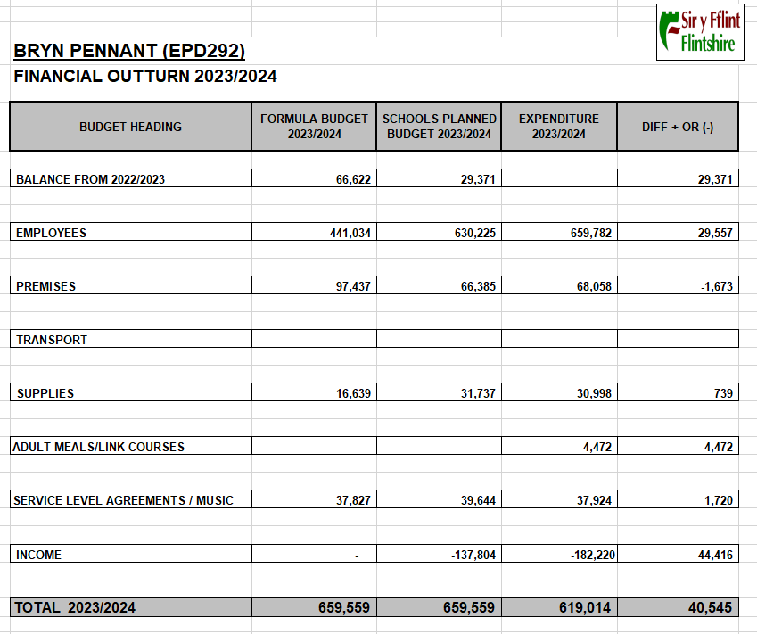

Attendance

Attendance is an area of particular concern and the way Flintshire supports primary schools with this has now changed. We now have a new EWO in place and she is very pro-active in her support for families who are struggling with school attendance. Flintshire County Council have a system in place to fine families if their children are persistent non-attenders. Persistent non-attendance is now considered to be anything less than 90%.

Attendance at school is crucial to a child's development and good attendance is actively encouraged within the school.

All absences, whether authorised or unauthorised are recorded electronically. Parents are asked to contact school by telephone on the first day of absence wherever possible. This ensures that staff know why children are absent and that they are safe at home. Parents can also use Schoolcomms to alert us to any absence or email the school directly.

All absences for which there is no satisfactory explanation will be followed up by the school on the first day of absence. The school also has a duty to report persistent lateness to the Education Authority. Parents are reminded that they have a statutory responsibility to send their children to school and are asked to promote good attendance with their children. The pace of the curriculum is such that even in a few days’ absence or lateness pupils can miss an enormous amount of learning which can often leave them struggling to catch up.

Punctuality is also very important and our Breakfast Club has a positive impact on punctuality. If a child is late for lessons it is disruptive to the class and the teacher and also means that those pupils miss the vital start to the first lesson of the day.

Please remember, the morning session starts at 8.55am with the doors opening at 8.45am. Breakfast Club starts at 8.15am. The following is a summary of the regulations:-

Authorised absence:
- When the child is ill or has dental/hospital/optician appointment that cannot be arranged for outside normal school hours.
- Bereavement
- Ten days annual holiday if there are valid reasons why they cannot be taken during the usual holiday period.

Unauthorised absence:
- Any absence other than for the above.
- Any absence for which a parent does not notify the school (by telephone, letter, email or word of mouth).

Our Attendance Target for 2023 – 2024 was 93%

Actual Attendance for 2023- 2024 was 88.7% The previous target will remain in place for the next academic year.

School Holiday Dates and Training Days.

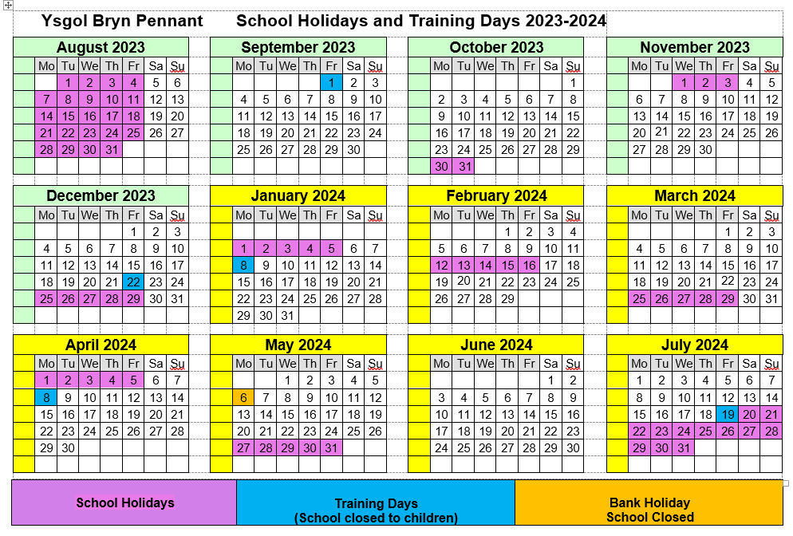

Closing Statement by Chair of Governors.
Ysgol Bryn Pennant is continuing to offer fantastic learning experiences for children in a caring and welcoming environment, and this against all the odds of the crippling cost of living crisis.
As Governors we are committed to supporting the school through what is looking like being an increasingly difficult financial position. We have tried hard to maintain our small classes as we feel that these provide the best opportunities for our children to progress in learning.
We are extremely grateful for all donations received during the past year, especially Mostyn Community Council and Kristina Howells Bingo which enabled the fitment of a CCTV system.
Immense pride is felt by everyone in the reputation of the school and its acknowledged good practices which continue to be admired and exemplified.
The run up to Christmas was as usual a busy time but the school still put on a brilliant Christmas Fayre involving staff and children alike which was well attended.
As Chair of the Governors my personal highlight was attending Year 4 and Year 6 Christmas celebrations at Christ Church.
The Governors have now appointed Parent Governors who we are confident will make a vital contribution to the school. Finally, as the School Governors of Ysgol Bryn Pennant it would be remiss not to acknowledge the crucial role played by Head Teacher Miss Wood and her staff, who continue to make the school what it is. Thank You.

Mr M. Lewis-Jones
Chair of Governors
September 2024

