
Ysgol Bryn Pennant

Prospectus
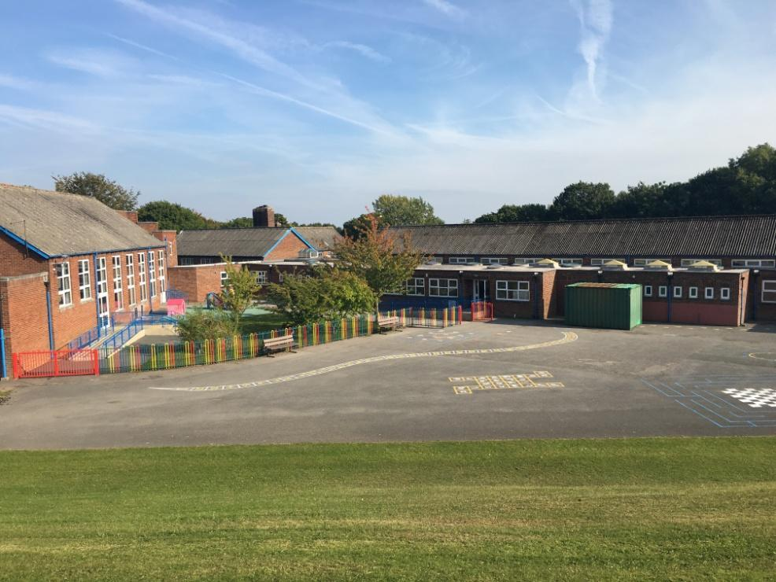

2025 - 2026
Contents
Welcome | 2
Our Mission Statement | 3
School Aims | 4
Our School | 6
School Details | 7
School Governors | 8
Teaching Staff | 9
Support Staff | 10
The Curriculum for Wales | 11
Assessment  Welsh  Forest School | 14  14  15
Facilities | 16
Safeguarding & School Security | 16
Key People and Contacts | 18
Attendance | 18
Attendance Data | 19
Additional Learning Needs | 19
More Able and Talented | 20
Relationships & Sexuality Education | 20
Equal Opportunities | 21
Pupils with Disabilities | 21
Religion Values & Ethics (RVE) and Collective Worship | 22
Homework | 22
Sporting Activities | 22
School Council | 23
Ethos | 23
Behaviour | 24
Healthy Schools | 25
School Meals | 25
Breakfast Club | 26
School Uniform | 26
Visiting the School | 27
Admissions | 28
Administration of Medicine | 29
Complaints Procedure | 30
Charging & Remissions | 30
High School Transition | 31
Note from the Headteacher | 32
School Holiday Dates and Training Days | 33

Welcome
Choosing the right school for your child is vitally important. Parents want a good education for their children but they also want them to be happy and to feel safe and secure. At Ysgol Bryn Pennant we believe we can offer all of these things and we pride ourselves on the broad, balanced and full education we provide for children aged 3 -11. The high standards of teaching and learning are a credit to the hard work of both staff and learners; we are equally proud of the atmosphere of friendliness and co-operation which is always evident.
Visitors to our school often comment on the warm welcome they receive and the excellent manners and exemplary behaviour of the children. Our school has succeeded in establishing a close family ethos in which all children feel valued and have their individual talents recognised and celebrated by everyone.
We believe that your child’s time in school should be rewarding and fulfilling; I look forward to meeting you soon and if you have any queries or concerns please contact me in school at any time.

Miss D. A. Wood, Headteacher

Our Mission Statement
In Ysgol Bryn Pennant we strive to provide a broad and balanced education, enabling our learners to become confident, independent individuals with a thirst for life-long learning. We pride ourselves on being a supportive, inclusive community, with wellbeing at its heart.

Our Motto
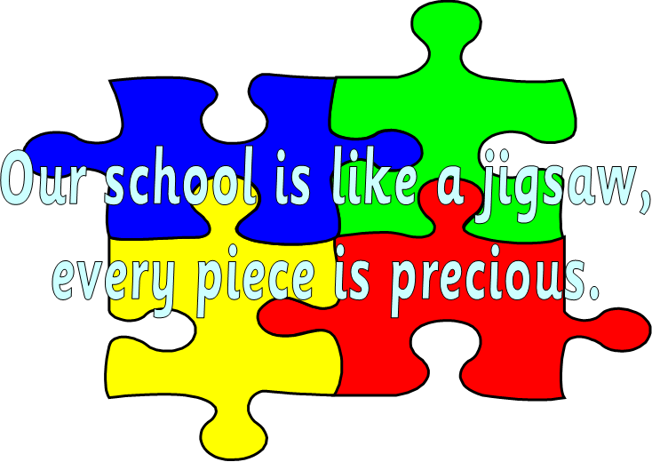

School Aims
In line with our school mission statement, our aim is to create a school environment in which all children are able to flourish into happy, independent and confident individuals. We aim to help our children grow into responsible members of society, aware of the needs of others.
We aim to provide the highest quality education to ensure that each individual within our school reaches their potential.
We aim to establish a nurturing learning environment based on high levels of mutual respect between pupils, staff, parents, governors and our local community.
Our prime concern is for the welfare of our children at all times.
While we are a small school, we pride ourselves on our family atmosphere. At present we have approximately 107 pupils on roll.
Ysgol Bryn Pennant is an English medium school for pupils aged from 3 – 11. Our pupils are organised into five classes of mixed ability, with two year-groups in each class. Nursery/Early-Entitlement children can join our school place in the term following their third birthday.
In September 2022, we re-organised our classes so that they match with the Curriculum for Wales Progression steps. We have named them after some of the trees which thrive in our school grounds.

Dosbarth Mesen Bach (Little Acorns) : Year One, Reception, Nursery and
Early Entitlement
Dosbarth Helygen (Willow): Years Two and Three
Dosbarth Scyamorwyddan (Sycamore): Years Four and Five
Dosbarth Derwen (Oak): Years Five and Six


From Little Acorns,
Might Oaks Grow!


Our School
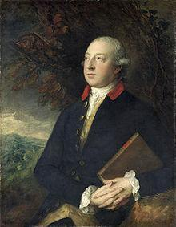
Our school is situated on the Maes Pennant Estate in the village of Mostyn. Mostyn is located on the North East Coast of Wales with Prestatyn and Flint lying approximately seven miles to the West and East, respectively. The school lies just off the A548 coast road which runs alongside the Dee Estuary. The village is set on a hillside overlooking the estuary and enjoys breathtaking views across to the Wirral, Liverpool and beyond. We are lucky to be situated in such a lovely, rural area.
Ysgol Bryn Pennant is named after Thomas Pennant, who lived in Downing Hall. He was celebrated as a famous writer and historian.
His most famous work is a series of books entitled ‘Tours of Wales’.
Our primary school was built in 1950 to educate the rapidly expanding local community.

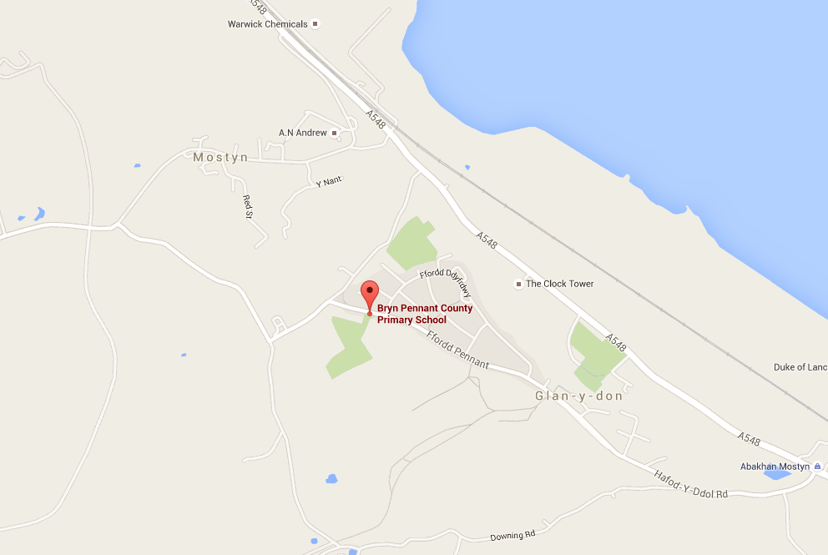
School Details
Name/Enw | Ysgol Bryn Pennant
Address/Cyfeiriad | Ffordd Pennant, Maes Pennant, Mostyn, Flintshire, CH8 9NU
URL: | www.ysgolbrynpennant.com
Telephone Number/Rhif Ffon | 01745 560 274
Headteacher | Miss Dawn A. Wood
Chair of Governing Body | Mr Michael Lewis-Jones
Type of School | Community Primary
Local Authority | Flintshire County Council

School Governors
Clerk to the Governors Mrs D. Newton
Chair (Local Authority Governor) Mr. M. Lewis-Jones
Vice-Chair (Community Governor) Mrs L. Jones
Local Authority Cllr. P. Banks
Parent Governors Mrs E. Lovgren
Vacancy
Vacancy
Community Governors Mr D. Seddon
Teaching Staff Governor Mrs L. Roberts
Non-teaching Staff Governor Miss K.Bennett
Headteacher Governor Miss D. A. Wood

Teaching Staff
Headteacher Miss D. A. Wood
Early-Entitlement Teacher/
Nursery & Reception Miss M. McAdam
Miss S. Warburton
Years 2 & 3 Teacher/ Mrs L. Roberts
A.L.N.Co.
Years 4 & 5 Teacher Miss E. Seddon
Years 5 & 6 Teacher Mrs V. Francis-Owen



Support Staff
Office Manager Mrs D. Newton
Breakfast Club Supervisors Auntie Paula
Auntie Shirley
Auntie Charlotte
Caretaker Mrs T. Davies
Relief Caretaker Auntie Paula
Catering Staff Auntie Jackie
Auntie Jackie
Teaching Assistants Mrs L. Hughes
Mrs M. Williams
Miss L. Roberts
Mrs D. Sharp
Miss N. Hennessey
Miss K. Bennett
Auntie Paula
Cleaning Staff Auntie Paula
Mrs M. Luke
Lunchtime Supervisors Auntie Shirley
Auntie Charlotte
Auntie Jenny
School Crossing Patrol Auntie Anwen
The Curriculum for Wales
‘The purpose of every school and setting's curriculum is to support our children and young people to be:
ambitious, capable learners, ready to learn throughout their lives.
enterprising, creative contributors, ready to play a full part in life and work.
ethical, informed citizens of Wales and the world.
healthy, confident individuals, ready to lead fulfilling lives as valued members of society.’
(Welsh Government 2023)
In Ysgol Bryn Pennant the children are encouraged to relate their learning to the Four Purposes from their earliest days in school.
They use our Four Purpose Power Monsters to help them with this.
Our Purpose Power Monsters are…

Enterprising Ethel Independent Ifan


Positive Polly Caring Cledwyn



The new curriculum is:
- a purpose-led curriculum – the four purposes are the
heart of curriculum development at a national and local level
- organised as a continuum of learning from ages 3 to 16 –
all children and young people will make progress along the same continuum
- organised around progression steps.
The Curriculum consists of Six Areas of Learning and Experience:
Language, Literacy and Communication
Mathematics and Numeracy
Health and Wellbeing
Humanities
Science and Technology
Expressive Arts

Each area of learning and experience is organised into a suite of what matters statements which prioritise the important concepts about which learners must have experiences, knowledge and skills.
Descriptions of Learning provide guidance on how learners should progress within each statement of what matters, as they journey through the continuum of learning.
Cross Curricular Skills of literacy, numeracy and digital competence are essential to all learning. Teachers plan for these across all areas of the curriculum.

Assessment
Assessment for learning is an integral part of school life. It is ongoing and includes self assessment, peer assessment and teacher assessment against success criteria. These strategies are used in all classes.
All learners from Year 2 – 6 complete the statutory Welsh Government Personalised Assessments in Numeracy and Reading.

Reflect

Develop

Learn

Welsh
At Ysgol Bryn Pennant lessons are delivered through the medium of English, however from the very earliest days in school children begin learning Welsh as a Second Language. In the New Curriculum for Wales, Welsh is part of the Language Literacy and Communication Area of Learning and Experience.
We are very proud to be a school in Wales and seek to foster an appreciation of Wales’ unique culture amongst our school community.
We celebrate St. David’s Day (Dydd Gwyl Dewi) by holding an in-school eisteddfod.
We have a very active Criw Cymraeg, made up of children from Years 2 - 6 and meet weekly and work hard to who promote the use of Welsh throughout our school. They also help organise as well as participate in our weekly Welsh Assemblies (Gwasanaeth Cymraeg).
All children are encouraged to use Welsh throughout the school day and across all areas of learning.

Each class has a Welsh mascot. The children enjoy taking these home for sleep-overs!

Forest School
Forest school gives children in all year groups the opportunity to develop confidence, social skills, self-esteem and independence through exploring the outdoors in a woodland setting. There is an emphasis on child led activities and plenty of opportunities for free choice and play. Children are encouraged to care for and respect others and their woodland environment.
Ysgol Bryn Pennant Forest School is based in an area of woodland within school grounds and also makes use of the school field. Sessions are run by Miss McAdam who is a Level 3 Forest School Leader and activities include den building, knot tying, mud kitchen, games, storytelling and singing. As sessions progress, fire safety and fire starting and the safe use of hand tools are introduced.

Facilities
Ysgol Bryn Pennant is set in spacious grounds and we have a secure outdoor learning area which is used daily by our Foundation Phase children. Our older children have access to an all-weather pitch, and extensive playing fields.

The school has a large hall and stage and a separate hall for dining. Our classrooms are generously sized and are light and airy.

Our toilet facilities were refurbished in 2013.
They comprise of: 4 toilets for Early Years Children
5 toilets for the Foundation Phase
4 toilets for Key Stage Two Girls
2 toilets/1 urinal for Key Stage Two Boys
1 toilet has wheelchair access
Hand washing facilities are available with each block of toilets.

Safeguarding & School Security
The safety and wellbeing of the children in our school is always our highest priority.
The school building and pedestrian access to the school grounds are secured at the start of each school day before registration commences.
Visitors are required to ring the doorbell at the main entrance, sign in on the ipad and wear a visitors badge before proceeding into the building. Visitors must also sign out when leaving.
New boundary fences are now in place to ensure that children are safe throughout the school day and when using the outdoor classroom areas or the playground.
Children from Early Years to Year 2 are not permitted to leave the school unaccompanied and must be collected by a responsible adult at the end of the school day.
Parents are also welcome to collect their children from Year 3 upwards however, these children are allowed to walk home at the end of the school day if their parents so wish.
Children who travel on the school bus to Rhewl will be accompanied to the bus by a member of staff. We ask that these children are met by a parent when they get off the bus in Rhewl.

School Times
Nursery/E.E. children | 8.55am – 11.30am
All other classes | 8.55am – 3.20 p.m.
We place a high emphasis on e-safety and aim to prepare children to be effective and safe digital citizens.
Staff follow Local Authority advice when they consider a child to be at risk in any way.
Our Safeguarding Policy and Health and Safety Policy may be viewed on request.

Key People/Contacts:
The Designated Person for child protection at Ysgol Bryn Pennant is:
Miss D. A. Wood, Headteacher
The Deputy Designated Person for child protection at Ysgol Bryn Pennant is:
Mrs L. Roberts, A.L.N.Co.
The Nominated Governor for child protection at Ysgol Bryn Pennant is:
Mr. M. Lewis-Jones, Chair of Governors
The Flintshire County Council Lead Officer for Safeguarding in Education is:
Mrs Vicky Barlow. Contact number: 01352 752121
Flintshire County Council’s Children’s Services can be contacted as follows:
Duty and Assessment Team. Contact number: 01352 701000
Out of Hours phone number (Duty Social Worker):
0845 053 3116
Attendance
Regular attendance at school is key to a child’s educational success and well-being. Attendance is monitored by the Headteacher and by the Local Authority.
The importance of punctual and regular school attendance cannot be over-emphasised. Late arrival can be upsetting to a child and be disruptive for the rest of the class.
Please notify the school, as soon as possible, either by phone or email if:
- Your child is absent from school.
- Your child needs to be collected from the school premises during the school day for any reason.
Applications for holidays of up to ten days during term time can be considered by the Headteacher. A holiday form can be requested from the school office. A child’s previous attendance record is taken into consideration before any holiday leave is authorised.
We provide details of each child’s attendance from the previous term at the beginning of each new term. Attendance levels are colour coded in a letter which also serve as reminders to parents of the importance of good attendance.
We have introduced ‘Attendance Passports’ which outline each child’s attendance in every calendar month throughout the school year.
Attendance Data
We actively monitor the attendance of all children as we believe good attendance is an important key to success. The Welsh Government now consider children with under 90% attendance to be persistent absentees. Our Governing Body set our attendance target for the academic year in the Autumn Term.
Additional Learning Needs
At Ysgol Bryn Pennant we recognise that all children are unique and develop their skills in different ways and with differing pace. Every child’s progress is monitored closely. If a child is identified as requiring additional support appropriate provision is put in place promptly. There are times when this will happen in a classroom context, there are also times when support is offered in small-group settings.
All Additional Learning Needs support at Ysgol Bryn Pennant is delivered in line with the Welsh Government Statutory Guidance. From January 2022, a new ALN Code started to be implemented and this will replace the old code completely by October 2025. The new requirements place the learner, and their family, at the heart of the process and we will work closely with parents to ensure the best possible outcomes for their children.
Children who are looked after by the local authority (LAC Pupils) are supported by our LAC coordinator, who works closely with the child or children, foster parents, and children’s services to secure positive outcomes for those concerned.
More information about Additional Learning Needs provision is available Mrs L.Roberts, our A.L.N.Co.
More Able and Talented Pupils
Children who are more able and talented are offered appropriate challenge and stimulation to ensure they make the greatest possible progress. This happens both within the classroom, and in smaller group settings.

Relationships and Sexuality Education
Relationships and Sexuality Education (RSE) is part of the Personal, Social and Health Education in our school. We participate in Flintshire County Council’s ‘Healthy School’s Scheme’ which promotes all aspects of health education.
We focus on supporting children’s physical, moral and emotional development.
Sex Education in Ysgol Bryn Pennant is about understanding the importance of stable and loving relationships that focus on respect, love, and care. Content is delivered by the class teacher in accordance with The Curriculum for Wales Relationships and Sexuality Education Code.
Since September 2022, a new law made it a requirement that all primary age children study relationships education and there is no longer an option for parents to withdraw their children from these lessons.
We encourage parents and carers to discuss the provision for Sex and Relationships Education with their child’s class teacher.
Equal Opportunities
It is essential that every child has equal access to education. Ysgol Bryn Pennant is committed to promoting equality of opportunity as outlined in the school’s Equal Opportunities Policy.
We recognise, and celebrate, the differences amongst all our children and members of staff.
Pupils With Disabilities
Our school can be entered by steps or ramps depending on need and we have toilet facilities which are accessible to wheelchair users. We work with appropriate agencies to ensure we provide for the needs of all pupils, irrespective of any disability.
Religion Values and Ethics (RVE) and Collective Worship
We believe that Religious Education and regular assembly forms a vital part of our family community. RSV forms part of the Humanities Area of Learning and Experience. Christianity forms a basis for this work. Throughout the school, children are taught about a range of other faiths in a way which is meaningful to them. Children gather daily in an act of collective worship.
Sharing Assembly is a celebration of children’s successes, whether these have been achieved in, or out of, school.
Homework
Full time children in Ysgol Bryn Pennant will be asked to complete weekly homework. The majority of homework is provided through Seesaw or Google Classroom, to which all children have access.
Although not exclusively, there is a focus on weekly reading and spelling which supports and builds upon the learning which children receive in school.
Parents are asked to support their children with all homework set.
Sporting Activities
Our school is set in beautiful, extensive grounds. We have a large playing field and all-weather pitch.

All children from Year Two upwards will have opportunities to participate in swimming lessons in Holywell Leisure Centre on a rota basis during the year. These lessons are given by the Centre’s swimming coaches or a teacher from school.
Many of our sporting activities are supported by our teacher-led After School Clubs.
School Council
Our School Council is elected annually in the Autumn Term with each year group from Year 2 – 6 voting for their peers to represent them.
The School Council an important pupil voice group.mmThe school council enhance opportunities for all pupils and are asked to contribute to some of our school policies, particularly our behaviour code. They organise fundraising events at different times throughout the year.
Ethos
We believe that a happy, caring environment is crucial if children are to develop and reach their full potential. Every member of staff has a responsibility to nurture positive relationships founded on mutual trust and understanding.
This ethos is underpinned by our Home School Agreement, which we ask all parents/carers to embrace and sign up to upon their child/children’s admission to school.

Behaviour
As a school we cultivate a positive working environment for all children based on a firm insistence on the highest standards of behaviour at all times. We believe that without a commitment to good discipline, effective teaching cannot take place.
It is essential that there is always the highest levels of respect between all members of the school community.
It is vital that parents support this policy for the benefit of all the pupils and staff. We expect the children to behave in a responsible manner, both to themselves and others. They are expected to show consideration, good manners, courtesy, and respect to and for themselves and others at all times.
As a school we promote good behaviour by ensuring that the teaching in school is engaging and stimulating, by showing that pupils’ efforts are valued, and that progress really does matter. Each class has its own set of rules which the children help to establish at the beginning of each school year. Pupils are well supervised throughout the school day and minor incidents of inappropriate behaviour are dealt with quickly. Joint solutions to any difficulties will be sought with parents at the earliest opportunity.
In addition to this we also believe that it is essential that children are praised for their successes and efforts, both socially and academically and, as such, we have a well-established rewards system in school. These include (but are not limited to!) awards from teachers, awards from the Headteacher, and celebrations of learners' achievements.

Achieve

Reward

Effort

Healthy Schools
As a school we are proud to be part of the ‘Healthy Schools’ scheme. Being part of the Healthy Schools scheme ensures that children receive a balanced diet during the school day and encourages them to make healthy choices independently. Children may bring or purchase a variety of fruit to eat at snack time and fresh water is available throughout the day. Children are encouraged to bring a clear water bottle to school, enabling them to drink whenever they wish during lessons and at playtimes. These can be purchased for £2.50 using the School Gateway app.
School Meals
Our school meals are prepared by Newydd catering in their Central Production Kitchen in Mold and transported into school. The school meals menu is displayed around school and is available on our school website.
All children in primary school in Wales are provided with a school meal free of charge. Children can select a meal daily using the CYPAD ordering system when they come into school and parents can also order food for their children in advance from home.

Breakfast Club
Every child in school is entitled to attend our free Breakfast Club in the morning. Breakfast Club opens at 8:15 am, and there are a range nutritious food choices available, which will help ensure children have the best possible start to each school day.



School Uniform
We expect all children to wear uniform. The wearing of the correct uniform helps to create a sense of belonging in each child which further instils our ethos of nurture and wellbeing.
Our school uniform consists of:
- A royal blue sweatshirt, fleece, or cardigan.
- A blue or white polo-shirt or blouse.
- Plain black or grey trousers, skirt, or joggers.
- Blue and white gingham dresses or black shorts.
- Plain black school shoes/boots or black trainers (no high-heels).

For P.E. children are expected to wear:
- Plain blue/black shorts.
- A plain white t-shirt.
- Black pumps for indoor work, suitable trainers for outdoor work.

For health and safety reasons we expect all long hair to be tied back. Children are not permitted to wear jewellery, however, children may wear a watch and ‘stud’ earrings if they wish. We do not consider extreme hairstyles appropriate for school.
Children may wear plain school uniform, however school badge embroidered items can be purchased online through our uniform supplier. Please contact the office for details.

Visiting the School
Positive relationships between home and school are very important to us. Parents are welcome to visit us in school; before or after the school day is always the best time to speak to your child’s teacher as impromptu visits may disrupt a lesson. Parents are very welcome to phone at anytime and we will arrange appointments to discuss any concerns at a time to suit everyone.

Prospective parents are invited to contact the school to arrange a visit during school hours in order to gain a better insight into the working environment of Ysgol Bryn Pennant.

Admissions
Flintshire County Council are the admitting Authority for schools in Flintshire. Applications for all school places are made online, directly to the Authority.
Children can be admitted into our Nursery/Early Entitlement Class in the term following their 3rd birthday.
Children can be admitted into any year group, at any time, but this is dependent on the availability of places within the year group.
Further information on the admissions process can be obtained from Gill Yates, County Hall, Mold.
Parents/Guardians of pupils transferring to other schools are asked to inform Mrs Newton in the school office, so that the receiving school can be forwarded the necessary records and information.

Administration of Medicines
There are certain circumstances where children will need to receive medication during the school day.

Children with Asthma:
We have a register of all children who have a diagnosis of asthma which is updated annually. We ask parents to keep us informed of any changes to these circumstances. Reliever (blue) inhalers are stored securely, and your child may access these whenever the need arises. Staff will supervise their use. Steroid (brown) inhalers, are not permitted in school.
Other Medication:
If your child has a long-term or ongoing condition we will work with you and the relevant health services to put a care plan in place. The School Nursing Team, based in Flint Clinic will help our families with these. Details of how the medication will be administered will be taken under guidance from the relevant medical professionals.
No other medication can be given by school staff. Children are not permitted to bring medication to school with them. Parents/carers are welcome to come to school during the school day to administer ‘over-the-counter’ medication, if they so wish.

Complaints Procedure
A document explaining arrangements may be examined in the school office.
Should you have a complaint, please follow the procedure outlined below:
- Talk about the problem with the class teacher,
- Contact the Headteacher
- Contact the Chair of Governors
- Contact Mrs Jane Borthwick, Flintshire Local Authority

Charging and Remissions
We offer a range of educational visits in order to enhance children’s learning experiences. All educational visits are linked to the Curriculum for Wales.
In order for educational visits to go ahead we ask for a voluntary contribution towards the cost of admission and/or transport. We reserve the right to cancel these visits if the cost cannot be met.
We are now a ‘cashless’ school and all payments need to be made through the School Gateway app. If you need any help with this, please contact Debbie in the office.

High School Transition
Most of the pupils in our school transfer to Ysgol Treffynnon, Holywell. This school was newly built for the start of the 2016-2017 academic year, and replaced the old Holywell High School. Others transfer to Prestyatun High School, St. Richard Gwyn or Flint HIgh School.
In order to ensure a smooth transfer to High School for all children there is a carefully planned transition process that is reviewed annually. Our headteacher is a member of the Ysgol Treffynnon transition team and works closely with the high school staff to help develop the plans for transition.
Year 6 who are moving on to Ysgol Treffynnon are invited to attend a residential trip with staff and pupils from the high school in the summer term before transfer. During this visit they have the opportunities to meet and become familiar with children from the other primary schools that feed Ysgol Treffynnon.

A Note from the Headteacher
We are a small, welcoming and inclusive school at the heart of our village community. Our staff work hard to support all our children and central to this are the positive relationships we have with our families. We believe that by working together we can support all our children grow into happy, healthy learners.
Thank you for taking the time to read our school prospectus. If you require any further information, please do not hesitate to contact me.
Diolch yn fawr,

Miss D. A. Wood

School Holiday Dates and Training Days



