Ysgol Bryn Pennant


Governors Report to Parents

2024 - 2025

Ysgol Bryn Pennant
Governor's Report to Parents 2024 - 2025
Autumn Term 2025

This report is for parents and guardians of pupils at Ysgol Bryn Pennant, Mostyn. The National Assembly for Wales requires that an Annual report on their governance of the school is delivered to parents and guardians in the Autumn Term of each academic year.
-------oOo--------
Contents of the Report
Governors
Governors Meetings
Governing Body Responsibilities
Our Mission Statement
Safeguarding
School Prospectus
Estyn Inspection and Post Inspection Action Plan
The School Development Plan and Our Development Priorities
Well Being
Grant Funding
New Curriculum for Wales
Class Organisation and Staffing
Numbers on Roll (September 2024)
Catering
The School Buildings and Grounds
Security Arrangements/Health and Safety
Parents Evenings
School Council
After School Clubs
School News and Community Links
Friends of Ysgol Bryn Pennant
Healthy Schools Policy
Swimming
Additional Educational Needs
Staff Training
School Results 2024 - 2025
Pupils with Disabilities
School Budget
Expenditure Summary
Attendance
School Holiday Dates and Training Days
Closing Statement by Chair of Governors
Governors

All school Governors are appointed for a four year term. The school year runs from September to July each following year. This report is on the period from September 2024 to the end of the summer term in July 2025. During the academic year 2024-2025, the Governing Body met on the dates listed below.
Minutes are kept of all Governors meetings by the Clerk to the Governors, Mrs Debbie Newton. Any queries regarding the work and minutes of the Governing Body should be directed to the Clerk of Governors or the Headteacher. Governors are able to claim legitimate expenses from the school budget. As yet no expenses have been claimed.

Ysgol Bryn Pennant Governors 2024 - 2025
Parent Governors
Emily Lovgren
Amy Teodorescu
Vacancy

Education Authority Governors
Cllr. Patrick Heesom
Cllr. Pam Banks
Mr Michael Lewis-Jones (Chair)

Minor Authority Governor
Mr David Seddon

Community Governors
Mrs Lin Jones (Vice Chair)

Staff Governors
Miss Karen Welsh
Mrs Anwen Howells

Headteacher
Miss Dawn Wood

Clerk to Governors
Mrs Debbie Newton

Headteacher
Miss Dawn A Wood

Governors’ Meetings

Autumn Term 2024 | 2nd October: AGM  21st November
Spring Term 2025 | 20th March 2025
Summer Term 2025 | 3rd July 2025

Governing Body Responsibilities

The Welsh Assembly Government has given a range of duties and powers to governing bodies under legislation. Governing bodies have a general responsibility for the conduct of their school with a view to promoting high standards of educational achievement. These include: -

- Managing the school’s budget in accordance with the Local Authorities financing scheme for maintained schools
- Making sure that the school’s curriculum is balanced and broadly based and in particular that the curriculum includes the National Curriculum and religious education.
- Reporting assessments and examination results to parents and the LA.
- Reporting results of the Statutory National tests to parents and the LA.
- Ensuring the appointment of the teachers and staff and determining how they will be managed including the provisions for staff discipline, complaints and grievances.
- Establishing in consultation with staff, a performance management and staff appraisal policy.
- Managing governors’ duties to pupils with Additional Educational Needs
- Drawing up an Action Plan following Inspections

Our Mission Statement
In Ysgol Bryn Pennant we strive to provide a broad and balanced education, enabling our learners to become confident, independent individuals with a thirst for life-long learning. We pride ourselves on being a supportive, inclusive community, with wellbeing at its heart.

Safeguarding
The safety and welfare of all our children is given the highest priority.
Children from Early Years to Year 2 are not permitted to leave the school unaccompanied and must be collected by a responsible adult at the end of the school day.
Parents are also welcome to collect their children from Year 3 upwards however, these children are allowed to walk home at the end of the school day if their parents so wish.
Children who travel on the school bus to Rhewl will be accompanied to the bus by a member of staff. We ask that these children are met by a parent when they get off the bus in Rhewl.
We have developed our curriculum to include learning opportunities to support the safeguarding of our children.
If you have any concerns for any of the children please do not hesitate to contact any of the key people listed below:
The Designated Person for child protection at Ysgol Bryn Pennant is:
Miss D. A. Wood, Headteacher
The Deputy Designated Person for child protection at Ysgol Bryn Pennant is:
Mrs L. Roberts, A.L.N.Co.
The Nominated Governor for child protection at Ysgol Bryn Pennant is:
Mr. M. Lewis-Jones, Chair of Governors
The Flintshire County Council Lead Officer for Safeguarding in Education is:
Mrs Vicky Barlow. Contact number: 01352 752121
Flintshire County Council’s Children’s Services can be contacted as follows:
Duty and Assessment Team. Contact number: 01352 701000
Out of Hours phone number (Duty Social Worker): 0845 053 3116

School Prospectus

The school prospectus is updated annually. It outlines our core values and contains information to help parents develop an understanding of how our school operates. It is routinely given to prospective parents when they visit the school. Copies of the prospectus are always available free on request to the school office. It can also be found on our school website.

Estyn Inspection & Post Inspection Action Plan

The school underwent an Estyn Inspection in November 2024.

Estyn identified the strengths of the school as well as areas they felt needed further development.
Estyn found that:

Ysgol Bryn Pennant Primary School is a caring and inclusive school, where staff know the pupils and families exceptionally well. Pupils are extremely proud of their school and show great kindness and care towards their friends. Most pupils have a positive attitude towards learning and make good progress from their starting points. They enjoy participating in pupil leadership groups, where they raise money for local charities. Nearly all pupils have a positive attitude towards the Welsh language and culture. They enjoy coming to school, and behaviour is exemplary.

Following the inspection, Action Plans were put in place to address the recommendations. There were two recommendations.

1. Sharpen self-evaluation processes to focus more specifically on the impact of teaching on learning and to ensure that pupils develop and build on their skills progressively R

2. Improve attendance and reduce levels of persistent absence

The school will continue to review its own performance through self-evaluation and the findings will inform the School Development Plan. Self-evaluation is a rigorous, continuous process, which is monitored, on a termly basis, by the school’s the Supporting Improvement Advisor, Paul Davies. This process will continue to be examined by external Inspectors.

The School Development Plan

Central to the running of the school is its improvement plan, which sets out in a written format a plan of the school's vision and purpose. The School Development Plan (SDP) is a written record of how the school is managing the business of delivering an education and learning provision for our school community. It is a key document for example that school Inspectors focus on in their review of a school. The SDP is under constant review on a three year cycle containing action plans and priorities for development over three years. A copy of the latest version is always available in school.

The School Development Plan is reviewed regularly by the Senior Leadership Team (SLT) and Governors. The priorities within the SDP are discussed in each of our meetings with Governors. This year we have invited our governors to become members of our curriculum teams which will help our governors to develop further within their monitoring roles. If parents have any queries on the content of any school policy, they should contact the Headteacher.

Our Development Priorities for 2024 – 2025 were:

Priority One: Identified Area for Development
Continue to improve teaching and learning for all through the development of pedagogy which supports progression.

Priority Two: Identified Area for Development
Through the further Implementation of the New Code for Additional Learning Needs, ensure that tailored provision is in place for all who need it.

Priority Three: Identified Area for Development
Increase the range of opportunities for pupils to develop their written literacy skills in all areas of learning across the curriculum.

Priority Four: Identified Area for Development
Develop Learners confidence and skills in using mathematics and numeracy across the curriculum.

Priority Five: Identified Area for Development
To further review and further develop Self-Evaluation Processes.

Additional Priorities
- Outdoor Learning - this is really encompassed in Priority One.
- Further enhance Pupil Voice
- Progression and Assessment - again has become part of Priority One
- Further develop collaboration with other consortium schools

Our SLT regularly monitor the school’s progress towards these priorities throughout the year.

Progress is also externally monitored by Paul Davies, our GwE Supporting Improvement Advisor. In addition, each Spring Term GwE monitor teaching and learning through visits to school. Paul met with teams of staff to help us review our progress and to decide on the next steps on our improvement journey. (GwE was disbanded in the Summer Term 2025 and there will be a new system in place by September 2025)

Wellbeing

Ysgol Bryn Pennant continues to be a nurturing school where the care and wellbeing of our children remains our highest priority.

Attendance is one area of particular concern and the way Flintshire supports primary schools with this has now changed. We have a new ESO in place and she is very pro-active in supporting the school and our families who are struggling with school attendance.

Throughout the school communication with parents has continued through text messaging (through Schoolcomms) as well as via email. These systems have facilitated closer and more regular communication between staff and parents and feedback from all stakeholders has been positive.

Grant Funding

In 2024–2025, the E.I.G. funding became part of the new Standards Grant. It was used to provide additional staffing which enabled the delivery of A.L.N. interventions and the development of outdoor learning resources. provision of basic skills support, delivered by some of our support staff.

It was also used to provide training for staff according to need and linked to the priorities identified in our School Development Plan.

The Pupil Deprivation Grant (PDG) and the Early Years Pupil Deprivation Grant (EYPDG, also now known as the Equity Grant, are the Welsh Government’s principal means of supporting schools to reduce the impact of a disadvantaged background on the educational attainment of pupils who receive Free School Meals (FSM) or who are Looked After Children (LAC).

These grants are intended to overcome the additional barriers that some learners face which prevent them from attaining as well as their peers, whatever their ability.

The targets for the PDG plan in 2024 – 2025 were focused on:

●Promoting well being through maintaining small classes
●Promoting engagement with learning in both the indoor and outdoor environments
●Narrowing the gap in attainment between pupils on F.S.M and non F.S.M. pupils through staffing to deliver and support interventions

The Professional Learning Grant became the Reform Grant. It helps schools provide access to professional development during the implementation of the New Curriculum for Wales. Our staff attended training opportunities both within our own school and in schools across our local area.

The ALN Implementation Grant allowed for our ALNCo to undertake further training and professional development opportunities to support her work as ALNCo. as the new ALNCO. continued to be implemented.

Class organization and Staffing

From Little Acorns, Mighty Oaks Grow

Our Early Years class, which is made up of our Nursery and Reception children was taught by Miss McAdam and Miss Warburton. Miss McAdam taught in the morning, and Miss Warburton, in the afternoon. This is our Progression Step One class.

They have further developed ‘Planning in the Moment’ which gives children more choice in the activities they select and can be tailored to the interests and strengths of individuals. This has also increased parental engagement with learning which is something we would like to continue to build upon.

Miss McAdam continued to provide woodwork activities in the ‘Beehive’ and supported children to independently create small models using a variety of real tools.

Miss Seddon taught a class of Years 1 and 2 in Dosbarth Celyn. The children enjoyed a wide range of experiences in all areas of learning.
This class also continued to benefit from Miss Seddon’s expertise in BSL.

Mrs Roberts taught a class of Years 2 and 3 in Dosbarth Helygen. (Progression Step 2). This class contained some of our most vulnerable children.

Miss Welsh taught Year 4 and younger Year 5 in Dosbarth Sycamorwydden. (Progression Step 3). The number of ALN children in this class was high and Miss Welsh had a variety of specific interventions in place to support these children.

Mrs Francis-Owen continued to teach Dosbarth Derwen (Years 5 and 6 / Progression Step 3). The children from this class support their younger peers from across the school at a variety of times during the school day.

In 2024-2025 the school roll remained steady. Our Local Authority admission number is 18 children per Year Group.

We welcomed a small number of Early Entitlement children into school in the Spring Term and in the Summer Term. These children attended along with our nursery children from 8.55 a.m. - 11.30 a.m. each day.

Numbers on Roll (September 2024)

Pupil Numbers  Sept.2024 | Class | Boys | Girls | Total in Class
Nursery | Mesen Bach  (Little Acorns) | 4 | 6
Reception | Mesen Bach  (Little Acorns) | 1 | 7 | 18
Year 1 | Dosbarth Celyn  (Dosbarth Holly) | 5 | 8
Year 2 | Dosbarth Celyn  (Dosbarth Holly) | 0 | 5 | 18
Year 2 | Dosbarth Helygen  (dosbarth Willow) | 3 | 7
Year 3 | Dosbath Helygen  (Dosbath Willow) | 8 | 6 | 24
Year 4 | Dosbarth Sycaorwyddeb  (Dosbarth Sccamore)) | 10 | 4
Year 5 | Dosbarth Sycamorwydden  (Dosbarth Sycamore) | 4 | 4 | 22
Year 5 | Dosbarth Derwen  (Dosbarth Oak) | 3 | 5
Year 6 | Dosbarth Derwen  (Dosbarth Oak) | 7 | 8 | 23
Totals |  | 45 | 60 | 105

In addition to the support provided for children with ALN within their classes, Auntie De also provided focused and bespoke support. Mrs Debbie retired from her role as ALN support in July 2024.

Mrs Lynn Hughes, Mrs Maree Williams, Miss Lyndsey Roberts, Miss Kelly Bennett and Miss Nikki Hennessey worked within the classes to provide support for the children. Ms Paula Mills worked as an apprentice T.A.

In September our three Midday Supervisory Assistants were Mrs Maree Williams, Auntie Shirley and Auntie Charlotte.

Catering
Newydd Catering continue to prepare and deliver our school meals to our School each day. We have received some concerns over the quality and quantity of meals from Newydd. These have been passed on to the company directly as we are not able to resolve these issues.

Mrs. Susan Jones who had worked in our school kitchen for approx. 35 years retired from her posts in both Breakfast Club and lunchtime catering Assistant in February 2025

Newydd Catering employed Auntie Jackie (Lloyd) as our new Catering Assistant. Auntie Jackie works to ensure the children are served their meals each day. She is supported by Auntie Jackie (Williams) who also works in school as a Catering Assistant.

The school continues to run a very successful Breakfast Club, providing free breakfasts to between 55 and 60 pupils each morning. In September, Breakfast Club was run by Auntie Sue, Auntie Paula and Auntie Shirley. Staff did change during the year.

Breakfast begins at 8.15am and closes at 8.45am, and offers pupils a choice of cereals, toast, fruit juice or milk as well as fruit. The children have access to a variety of resources and activities thus ensuring that they are happily engaged and can spend time with their friends before they go into class to start the school day.

The school was cleaned and maintained by the school caretaker Mrs. Tina Davies assisted by Mrs Marie Luke and Ms Paula Mills.

All our administration is undertaken by our Office Manager, Mrs Debbie Newton.

The School Buildings and Grounds

Our building is showing signs of age in some areas and during the year 2024- 2025, Flintshire County Council completed the full refurbishment of our flat roof. It is now watertight and it is hoped that the increased insulation will help to reduce our fuel bills in the winter.

The footpath which was installed by Kingspan in September 2017 had become significantly eroded and despite several attempts at having it repaired, Estyn raised it as a site safety issue. The only way to rectify the issue was to have the path removed completely. This work was completed in the Spring Term and the ground is recovering well.

Mrs Robers has been working on developing ‘Daffodil Yard’ to enable more facilities for outdoor learning.

Security Arrangements / Health and Safety

The annual Health and Safety Audit was carried out by Mr. David Seddon during the Autumn Term and discussed with Miss Welsh, our Teacher Governor who served as a member of the Health and Safety Committee.

The main findings were

● The surface to the car park is still in need of repair
● There is a need for internal painting and decorating
● The guttering and downpipes need to be repaired/replaced
● Shortage of covers for manholes and drains

Following the audit, a report was once again sent to the L.A. and we are awaiting a response.

During the Summer Term, we underwent a full Health and Safety audit carried out by Flinthshire County County. As a result of this, it was suggested that we increase the height of our external fence further to the right of the driveway. This is something we are now working to secure funding for.

Parents Evenings

We held Parents evenings in the Autumn and Spring Terms. This gave parents opportunities to meet with teaching staff and discuss each child’s individual progress and targets for next steps. These were very well attended. We continue to encourage parents to contact us promptly if they have any concerns.

Parents were provided with their Child’s annual report in the Summer Term and encouraged to discuss any concerns with class teachers directly. The results of the Welsh National Tests were also reported to parents in the summer term.

School Council
The School Council were re-elected in September 2024. They organized and ran fundraising events and contributed to pupil vice throughout the school year.
After School Clubs
After School Clubs were offered to all children from Years 1 - 6 during the school year. Clubs on offer included Creative Club, Outdoor Club and Sports Club. All teaching staff helped to run activities on Monday afternoons after school.

The teachers continued to run a weekly homework club for their own classes so that the children could have some additional help with their homework if they needed it.

School News and Community links

We have continued to use School Gateway to message parents through email and text and all payments for items such as school water bottles and snack now have to be made through the system. Nearly all families are able to use these systems.

Our new school website is now up and running and is a valuable source of information for parents and carers.

We held a very successful and well-attended Christmas Fair in early December and our Summer fair was held on a Friday afternoon in June. There were a variety of stalls at both the events and many fun activities for children and their families to enjoy. We are thankful for the support received from our families and the wider community and the events raised some much needed funds.

Our monthly Luncheon Club to which we invite older members of our Community continued throughout the school year. Our children take turns to welcome these visitors and to serve them with their roast dinners. We also invite them to participate in special activities during the year. We pride ourselves on these opportunities for intergenerational working.

Friends of Ysgol Bryn Pennant

Throughout the year Friends of Bryn Pennant organized and supported a variety of events which have brought in much needed additional funds. Money raised has meant that we have been able to offer subsidised transport and costs of out of school visits to all children to support their learning.

Funds raised have also been used to support our Breakfast Club which we are determined to ensure stays free of charge to all our children.

We purchased Leavers Hoodies for all our Year 6 leavers and they were able to wear these in the Summer Term.

Healthy Schools Policy

We are committed to the Healthy Schools Project and provide a fruit-only snack which can be purchased along with milk. There is no charge for milk for children up to age seven. Sweets, biscuits and crisps are not allowed for snack although we do allow a chocolate biscuit or crisps as an occasional treat in a packed lunch brought from home. The children are used to this and adhere to it as a matter of course.

Water is available throughout the day from the water coolers in the school corridor. We encourage all children to bring their school water bottle daily and every child is given one of these when they start in school.

Our school meals, which are now provided by Newydd Catering via the Central Production Kitchen in Mold are compliant with the Flintshire Healthy Schools Policy. Children have a choice of two hot meals each day, and the option of a packed lunch, pasta or a filled jacket potato on different days throughout the week. The number of families we have who are entitled to Free School Meals has risen to approximately 61%.

Swimming

During 2024 – 2025, all children in Dosbarth Derwen, Dosbarth Sycamorrwyddan and Dosbarth Helygen attended blocks of swimming within their class groups. Year 2 children from Dosbarth Celyn joined Dosbarth Helygen so that they could access swimming too. The lessons take place in Holywell Leisure Centre. The costs of these lessons and the transport is subsidized by the school.

Additional Learning Needs

The new Code of Practice for ALN continued to be implemented during the academic year 2024 - 2025.

We work closely with a wide range of outside agencies to ensure provision is closely matched to the needs of individual children whenever this is necessary.

The statementing process has now been replaced and children with more complex needs are supported through Local Authority based IDPs.

Our Additional Learning Needs Policy is now the New ALN Code. Should you wish to read it or discuss any aspect of the school's additional needs provision, please do not hesitate to contact the Headteacher, Miss D. A. Wood or the schools A.L.N.Co. Mrs L. Roberts. The school's Additional Needs Governor is Mrs Lin Jones.

Mrs Roberts, as our ALNCo, has continued to support the teaching staff with Provision mapping. These are regularly reviewed to ensure that the needs of all children are met.

We will continue to work with parents to ensure that they are fully involved in the process as parental involvement and person centered planning are key features of the new ALN process.

Staff Training

All staff, teaching and non-teaching at Ysgol Bryn Pennant are given the opportunity to improve their skills and knowledge through ongoing professional development.

All teaching staff continue to be subject to Performance Management arrangements which are monitored by the Governors.

In 2024–2025, staff development priorities were in line with the School’s Development Plan. The wellbeing of all members of the school community continues to be prioritised and remains at the heart of the work we do.

In September, Level 1 Safeguarding Training was attended by staff to whom this applies. We have three staff trained to Level 2 (Mrs Newton, Mrs Francis-Owen and Miss Warburton). Miss Wood and Mrs Roberts, both have Level 3 training. There are currently some changes to the system being implemented and the categories of training are being updated.

In addition to this all staff have been asked to undertake Prevent (re-training) and to update their training in VAWDADV (Violence Against Women, Domestic Abuse and Sexual Violence). Both of these are required for all school based staff.

School Results 2024 - 2025

The progress which each child has made during their journey through each stage of their education is used by individual schools to monitor and assess the effectiveness of its educational provision. We have introduced a new tracking system which will help to ensure that the progress of all our children can be more closely monitored as they move through each academic year.

The Welsh National Tests were undertaken by all learners from Years 2 to Year 6 and the results of these reported to parents. Teaching staff use the results of these and other standardized assessments to inform future teaching and learning.

Our teachers collaborate with other schools in the local area to moderate and review pupil’s work and progress.

Pupils with Disabilities

The school building is wheelchair accessible and there is a toilet which has been adapted to accommodate a wheelchair. We do not, at present, have any wheelchair users on roll.

There are ramps to the infant cloakroom entrance and to the rear of the hall. Although we have a marked disabled parking bay by the front entrance, there is currently no ramped access to the front of the building. This is something which the Governors would like resolved.

School Budget

The school budget is a statement of income and expenditure over the school year, which runs from September to the end of August. The money for the school is delegated from the Education Authority, and its spending is under the control of the Headteacher and the Governors on behalf of the Local Authority. Our finance officer, Nicky Humphries helps to monitor the budget and all expenditure.

At the beginning of the Spring Term 2025, our Finance Officer confirmed that we were once again likely to face a deficit budget. Miss Welsh decided that she would like a new adventure and so successfully secured herself a new teaching post in Dubai. This meant that we did not need to go through the redundancy process. The Governors wish Miss Welsh all the best in her new post.

The changes to support staff hours that were offered by members of staff when we were facing a voluntary redundancy situation in Spring 2024, came into effect in September 2024. The Governing Body remains very grateful for their support.

There are several main areas of expenditure. The principal one being the teacher/staffing budget. These are costs that are not under the control of the school because teacher salaries are determined by the Welsh Assembly. The school receives a Foundation Phase grant which allows us to employ the required number of teaching assistants to support learning in the Foundation Phase.

The other main areas of expenditure are capitation (books and supplies), services (general maintenance and grounds maintenance), and energy costs which are continuing to rise.

We have a large building which is showing its age. Maintenance costs are rising, we have a growing number of faults which need rectifying.

Expenditure Summary

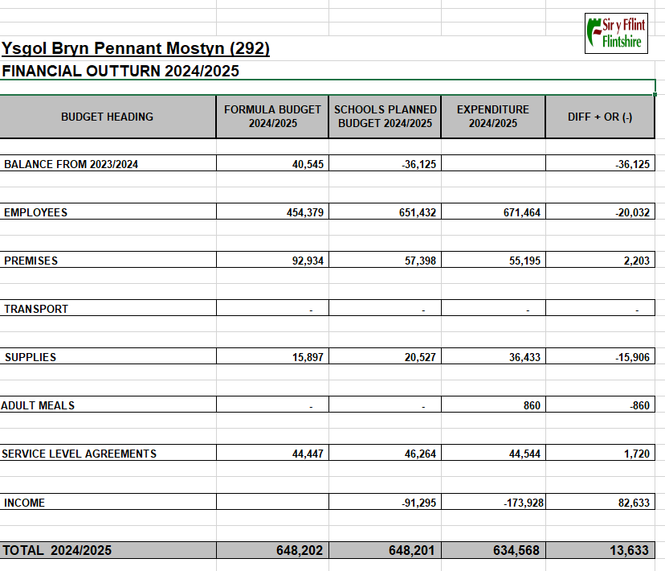

Attendance

Attendance is an area of particular concern and the way Flintshire supports primary schools with this has now changed. We now have a new ESO in place and she is very pro-active in her support for families who are struggling with school attendance. Monthly attendance meetings are held between our ESO and the Headteacher.

During our Inspection in November, Estyn found that our absence levels are too high and that we have too many children who are persistently absent. We have a new Attendance Action Plan in place to try and address some of the barriers to attendance.

Flintshire County Council have a system in place to fine families if their children are persistent non-attenders. Persistent non-attendance is now considered to be anything less than 90%.

Attendance at school is crucial to a child's development and good attendance is actively encouraged within the school.
All absences, whether authorised or unauthorised are recorded electronically. Parents are asked to contact school by telephone on the first day of absence wherever possible. This ensures that staff know why children are absent and that they are safe at home. Parents can also use Schoolcomms to alert us to any absence or email the school directly.

All absences for which there is no satisfactory explanation will be followed up by the school on the first day of absence. The school also has a duty to report persistent lateness to the Education Authority. Parents are reminded that they have a statutory responsibility to send their children to school and are asked to promote good attendance with their children. The pace of the curriculum is such that even in a few days’ absence or lateness pupils can miss an enormous amount of learning which can often leave them struggling to catch up.

Punctuality is also very important and our Breakfast Club has a positive impact on punctuality. If a child is late for lessons it is disruptive to the class and the teacher and also means that those pupils miss the vital start to the first lesson of the day.

Please remember, the morning session starts at 8.55am with the doors opening at 8.45am. Breakfast Club starts at 8.15am. The following is a summary of the regulations:-

Authorised absence:
- When the child is ill or has dental/hospital/optician appointment that cannot be arranged for outside normal school hours.
- Bereavement
- Ten days annual holiday if there are valid reasons why they cannot be taken during the usual holiday period.

Unauthorised absence:
- Any absence other than for the above.
- Any absence for which a parent does not notify the school (by telephone, letter, email or word of mouth).
- Our Attendance Target for 2024 – 2025 was 91%

Actual Attendance for 2024- 2025 was 86.13%. The target 0f 91% will remain in place for the coming academic year.

School Holiday Dates and Training Days.

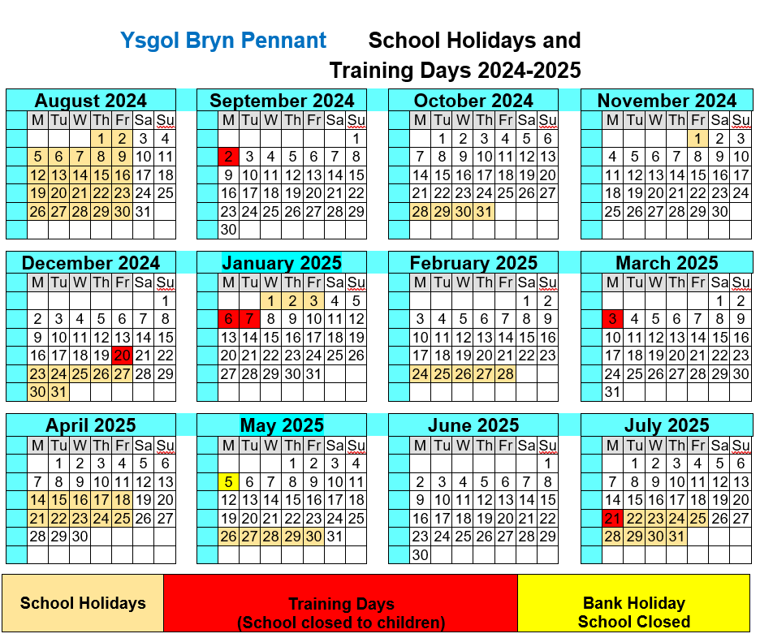

Closing Statement by Chair of Governors.
Autumn Term 2025

The time is upon us again to reflect upon the year at Ysgol Bryn Pennant. A school is nothing without its children and we are so pleased that the reputation of Ysgol Bryn Pennant is second to none which is all thanks to the excellent behaviour of the children. They are a credit to their parents and guardians.

The Governors of Ysgol Bryn Pennant are pleased to report that the school has continued to thrive under the leadership of Head Teacher Dawn Wood and her fantastic staff. The learning experiences for the children are second to none and Ysgol Bryn Pennant continues to be a shining beacon in our supportive community.

During the year Ysgol Bryn Pennant was subject to an Estyn Inspection, His Majesty’s Inspectorate for Education and Training in Wales. The Head Teacher, staff, children and Governors were interviewed and monitored by Estyn to rate the performance of the school. I am happy to report that all the continuing hard work and effort meant that Estyn is highly positive about the way that the school operates.

The School Governors of Ysgol Bryn Pennant would like to thank the Head Teacher Miss Dawn Wood and her staff, who continue to make the school what it is.

Mr M. Lewis-Jones
Chair of Governors
Autumn Term 2025

